**EE2-08C: Numerical Analysis of ODEs/PDEs using MATLAB**

**Introduction**

-Numerical methods etc

- 3 questions assigned

**Question 1** – RL Circuits

We will implementing numerical solutions for several inputs of the RL circuit shown in figure1 using the Heun’s Method. In the case where R = 0.5 Ω , L = 1.5 mH , Vin is a sine wave with amplitude V¯in = 5 V and period T = 60 ms, and initial state iL(0) = 0A, also obtain the exact solution of the first-order linear ODE and compare the numerical solution with the exact solution. We will be investigating ow does changing h (the interval) affects the accuracy. Heun’s method procedure of implementation is given as follows:

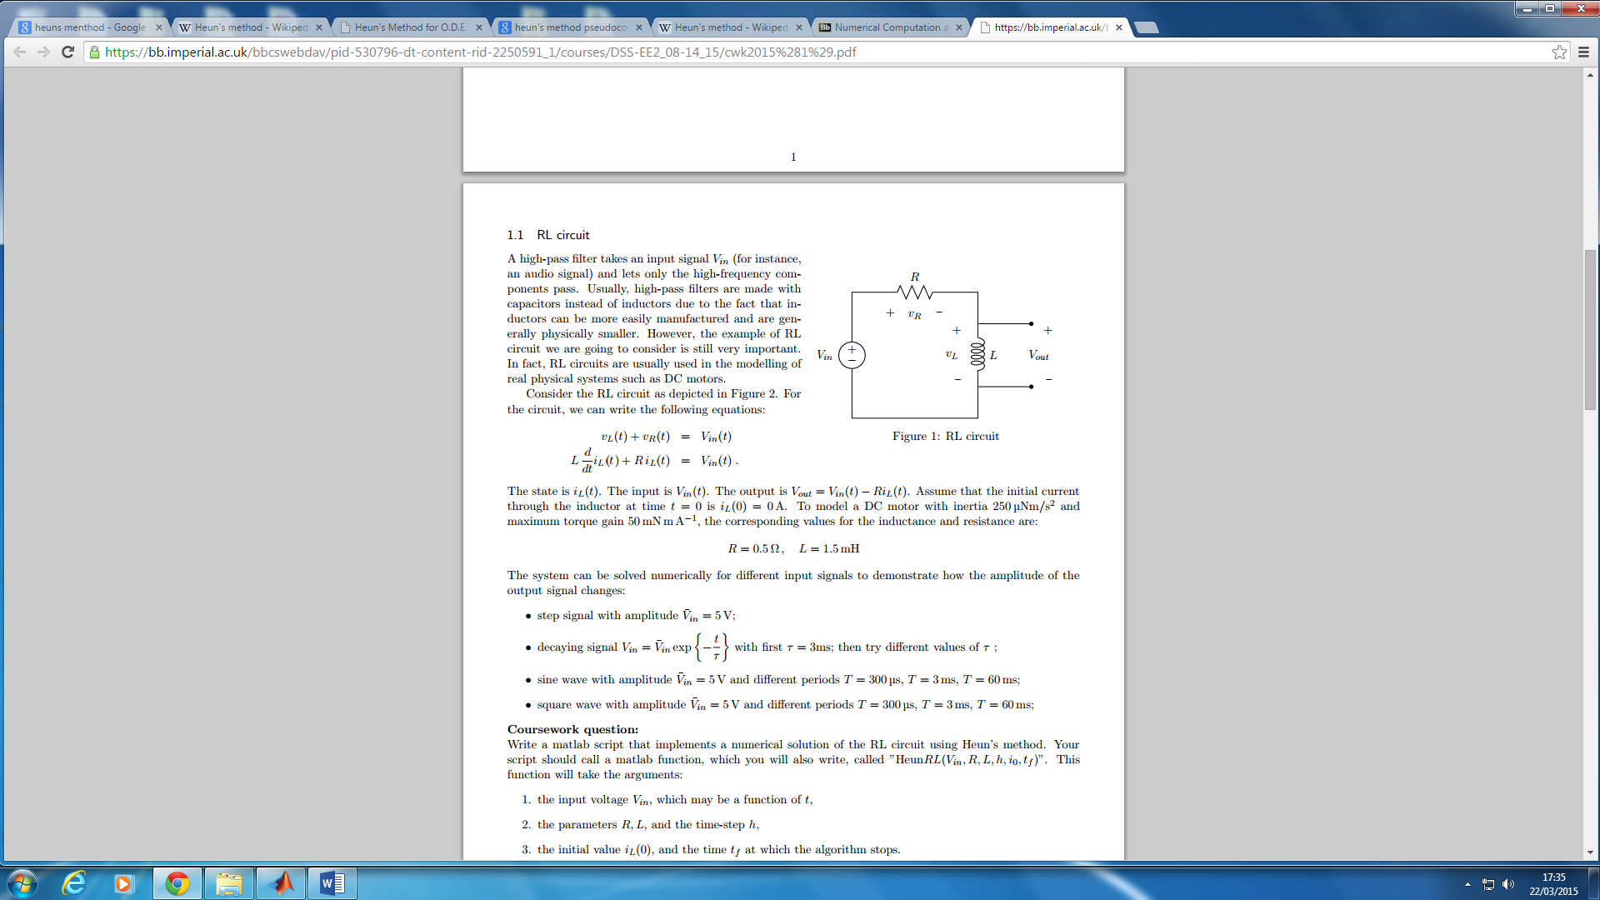**Heun’s method psudeocode:**

1. Initialise time to equal zero
2. The number of steps taken for iteration is: (interval size)/(step size)
3. loop for N steps
4. Predictor for the next value by taking the average gradient over (x, x+h)
5. Increase x by stepsize for next integration

**Heun function**

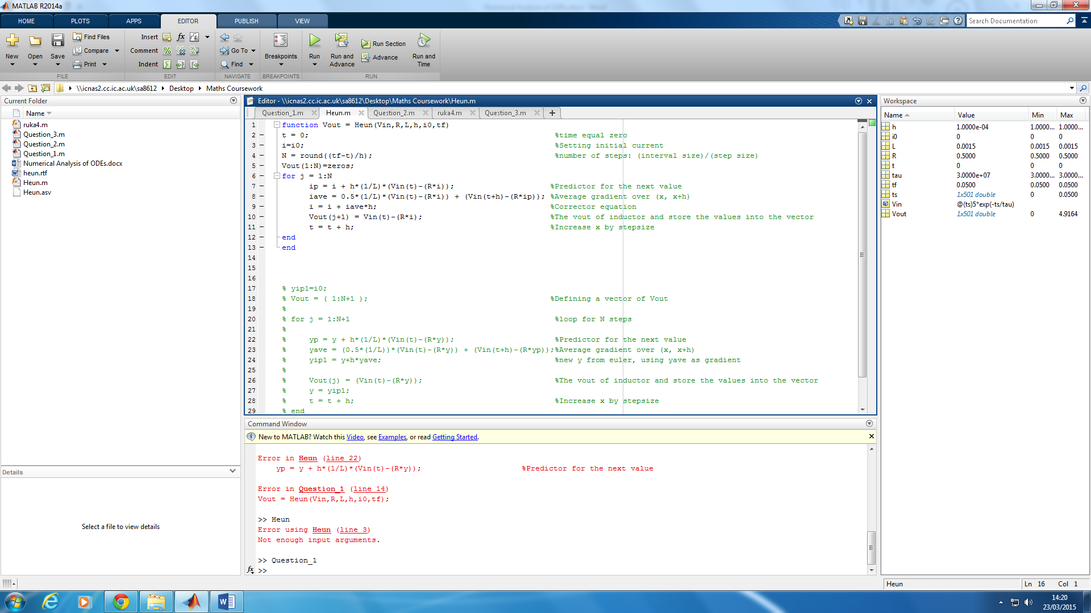

**All the cases for various input type needed for testing:**

1. Single step response of Vin = 5 Volts
2. Decay Exponential Vin = V’inexp() with

* τ = 3ms
* Varying values of

1. Sine Wave with amplitude V’in = 5 Volts for amplitudes

* T = 300 µS
* T = 3ms
* T = 60ms

1. Square wave V’in = 5

* T = 300 µS
* T = 3ms
* T = 60ms

***Case 1 – Step Input***

For the first case will be analysing the output response when the input is a step-input also known as the Heaviside function with a amplitude of 5 Volts. Below is the code to execute the following piece of code

Code Implementation

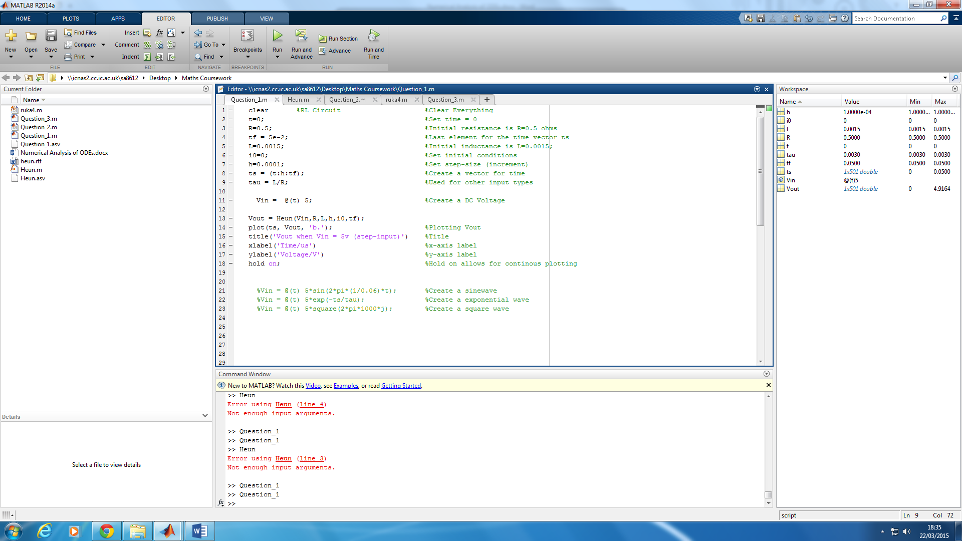

Results/Output achieved

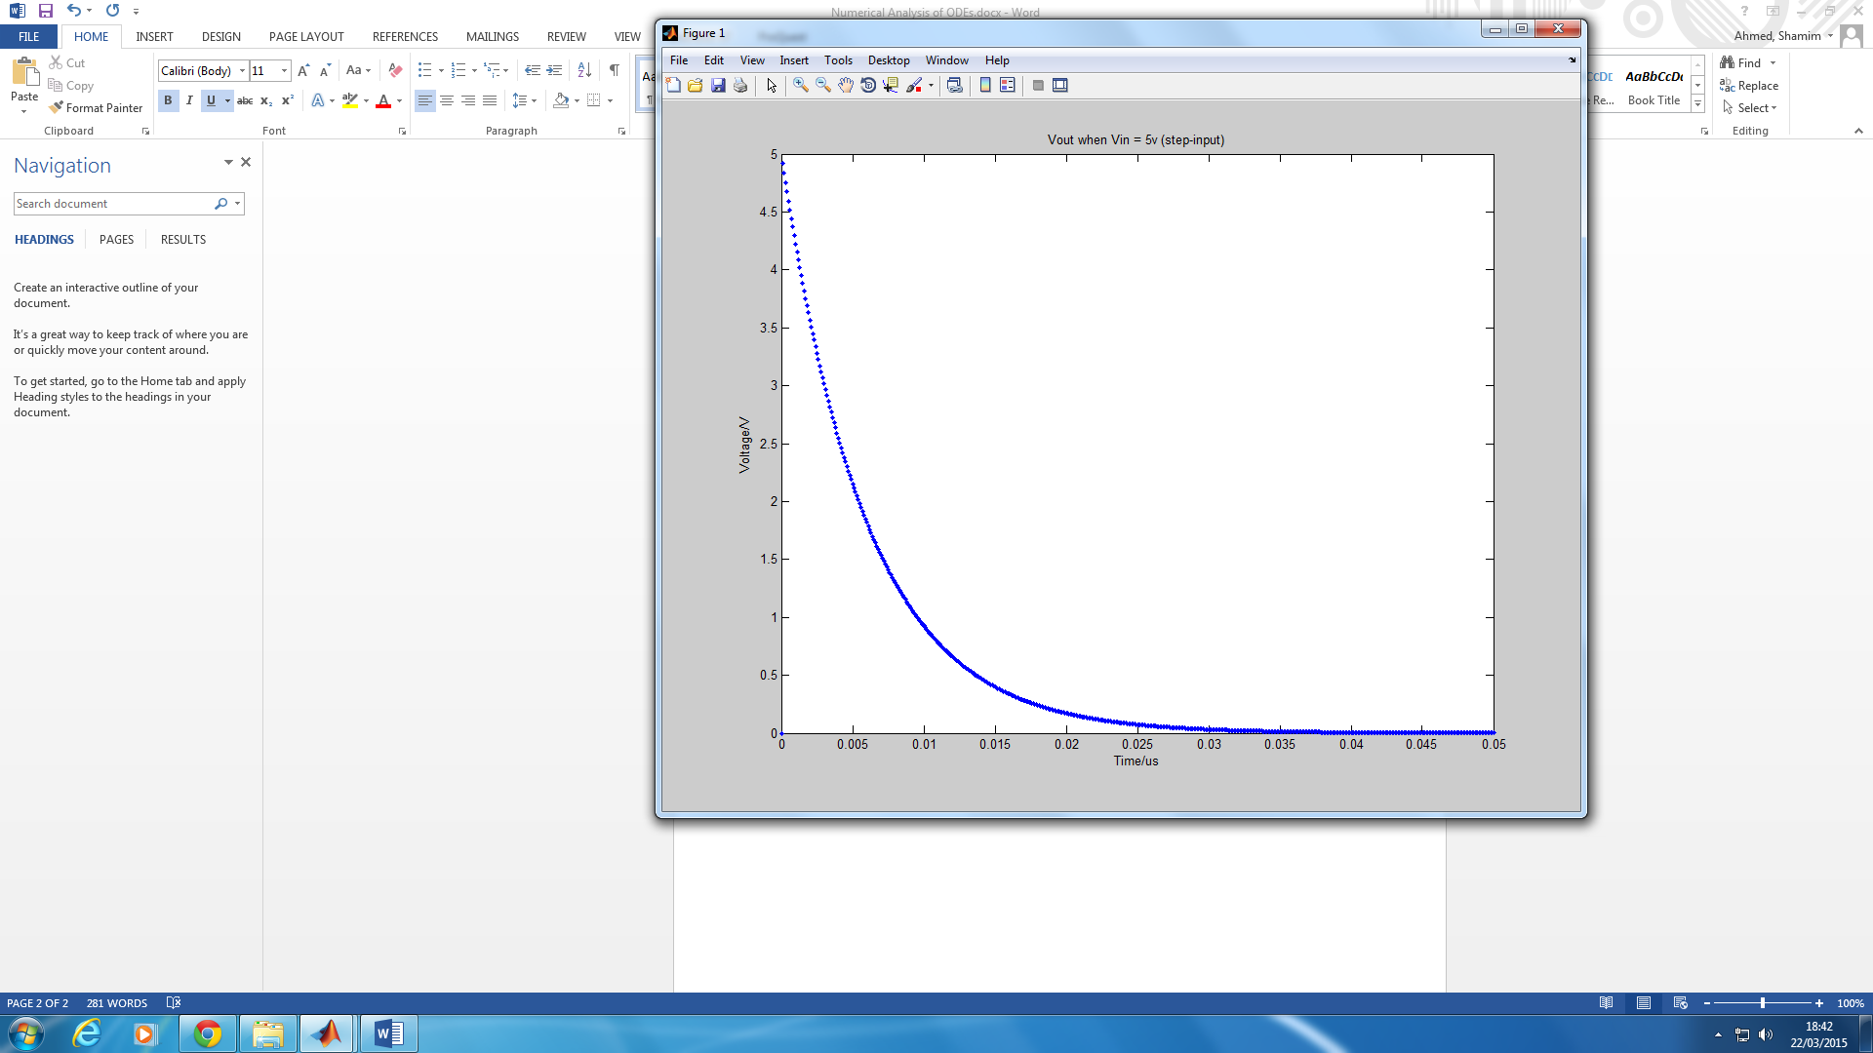

***Case 2 – Exponential Input***

For the second case will be analysing the output response when the input is a exponential input. Below is the code to execute the following piece of code

%Vin = @(ts) 5; %Create a DC Voltage

Vin = @(ts)5*exp(-ts/tau); %Create a exponential wave

Results/Output achieved

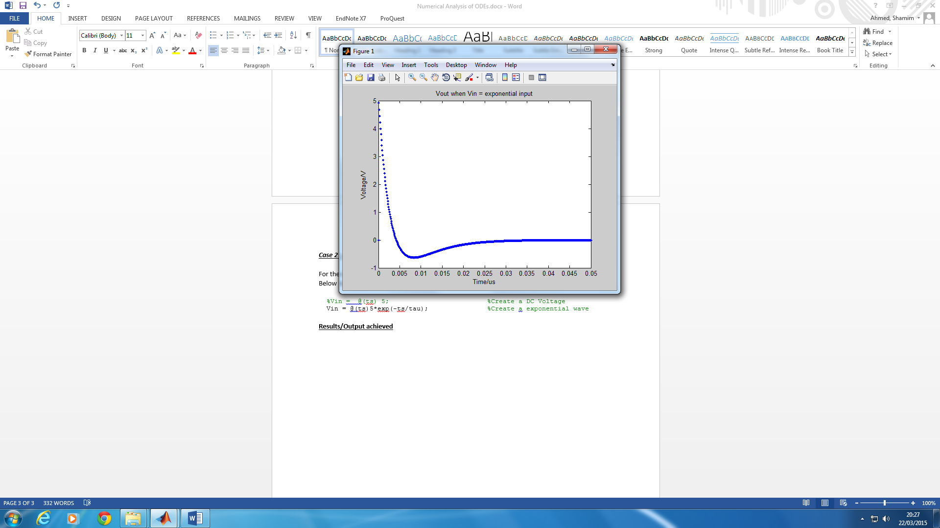

For varying tau values the curve starts to form into a linearized function

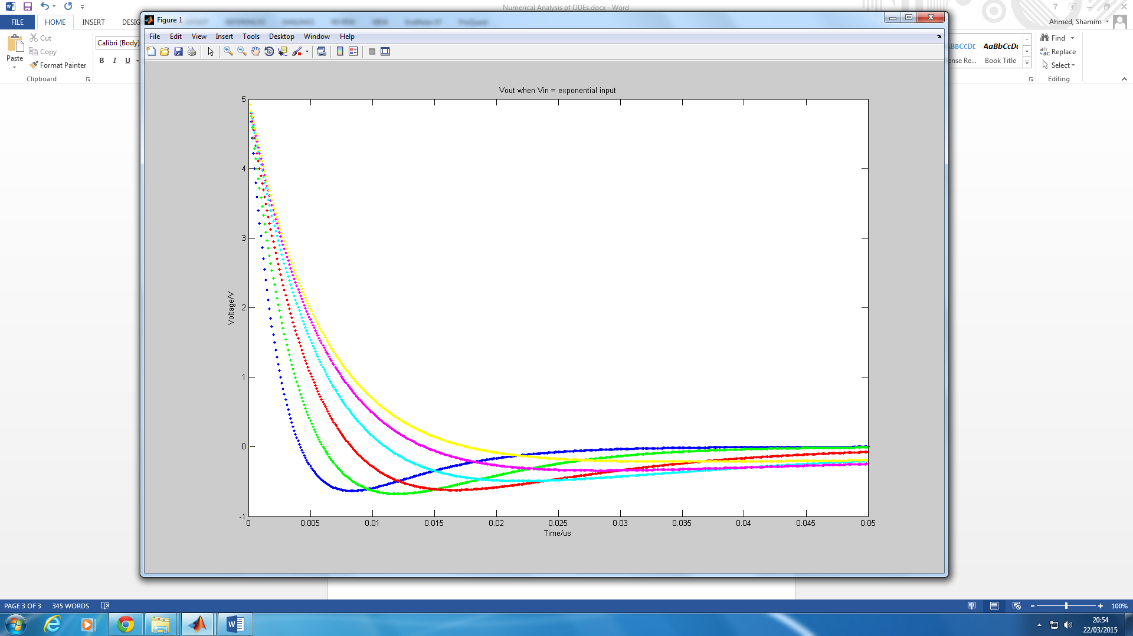

***Case 3 – Sinusoidal Input***

For the second case will be analysing the output response when the input is a Sinusoidal input. Below is the code to execute the following piece of code

%Vin = @(ts) 5; %Create a DC Voltage

%Vin = @(ts) 5*exp(-ts/tau); %Create a exponential wave

Vin = @(t) 5*sin(2*pi*(1/0.06)*t); %Create a sinewave

Results/Output achieved

